**Portfolio**

|  |  |
| --- | --- |
| |  | | --- | |  | |
| **Presented By :**  **MD : Tareq Hasan**  **Software Developer.**  **Phone: 01737853928 , 0151613249**  **Email: tareqhasanconcord@gmail.com** |

# Project Link:

|  |  |
| --- | --- |
| **Project Name** | **Project Link:** |
| **FXPP (Forexmart)** | <https://www.forexmart.com/> |
| **Client cabinet (FXPP -My)** | <https://my.forexmart.com/client/signin> |
| **FXPP Admin** | <https://m7.forexmart.com/> |
| **ZXY ERP** | <http://mis.zxyinternational.com/> |
| **REHAB BD** | <https://www.rehab-bd.org/> |
| **First Finance** | <https://www.first-finance.com.bd/> |
| **NGO Foundation** | <http://www.ngofoundation.org.bd/> |

# Some Local Project Screenshot:

**ERP for ZXY bd.**

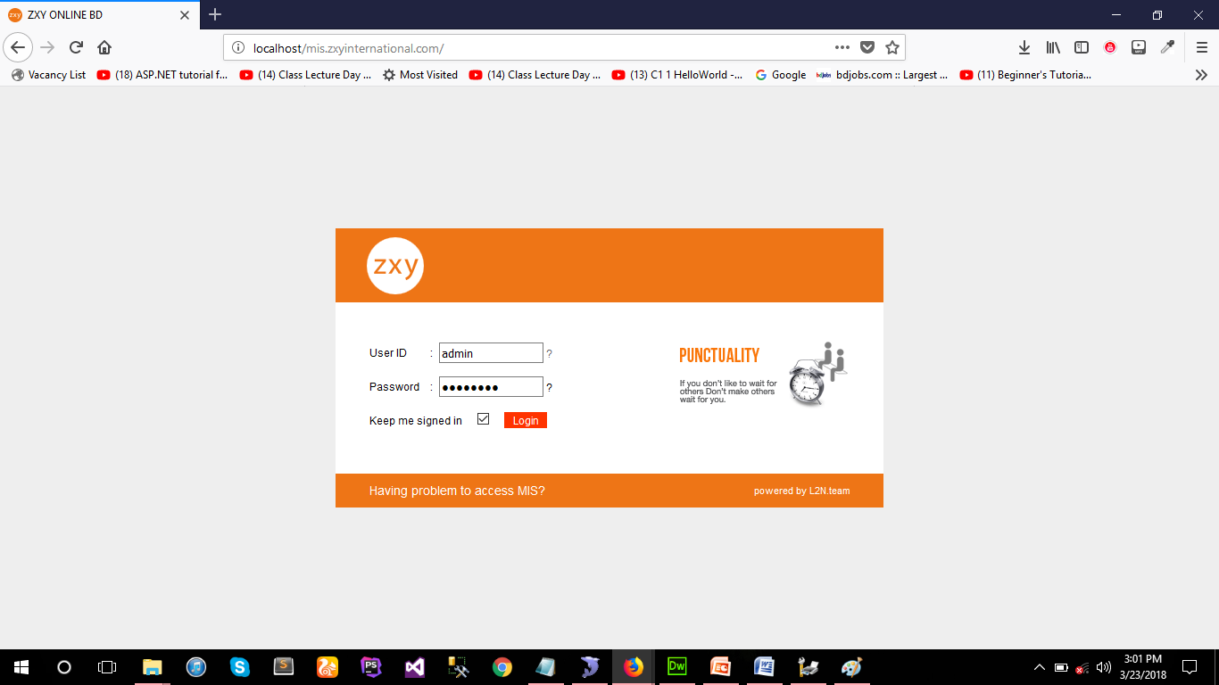

**Fig: Login Page**

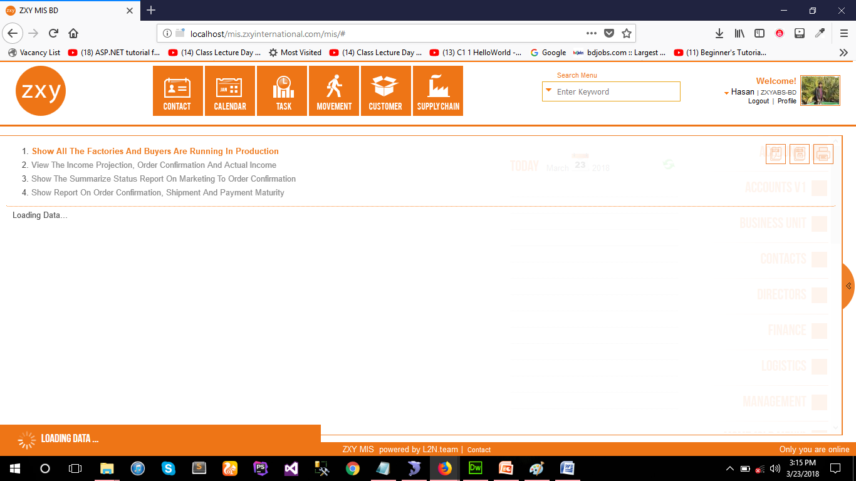

**Fig: Dash Boards**

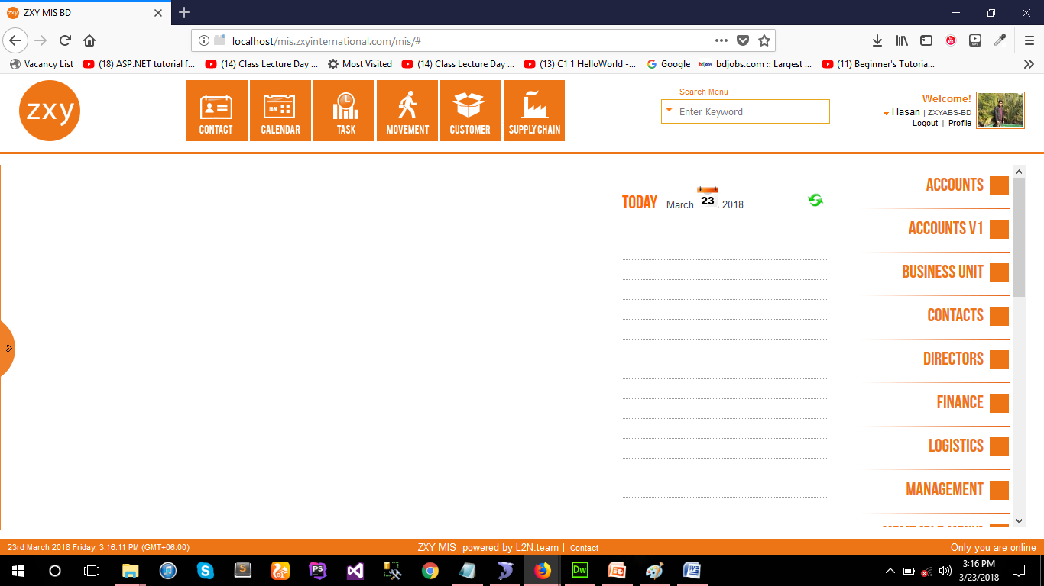

**Fig: Main Page**

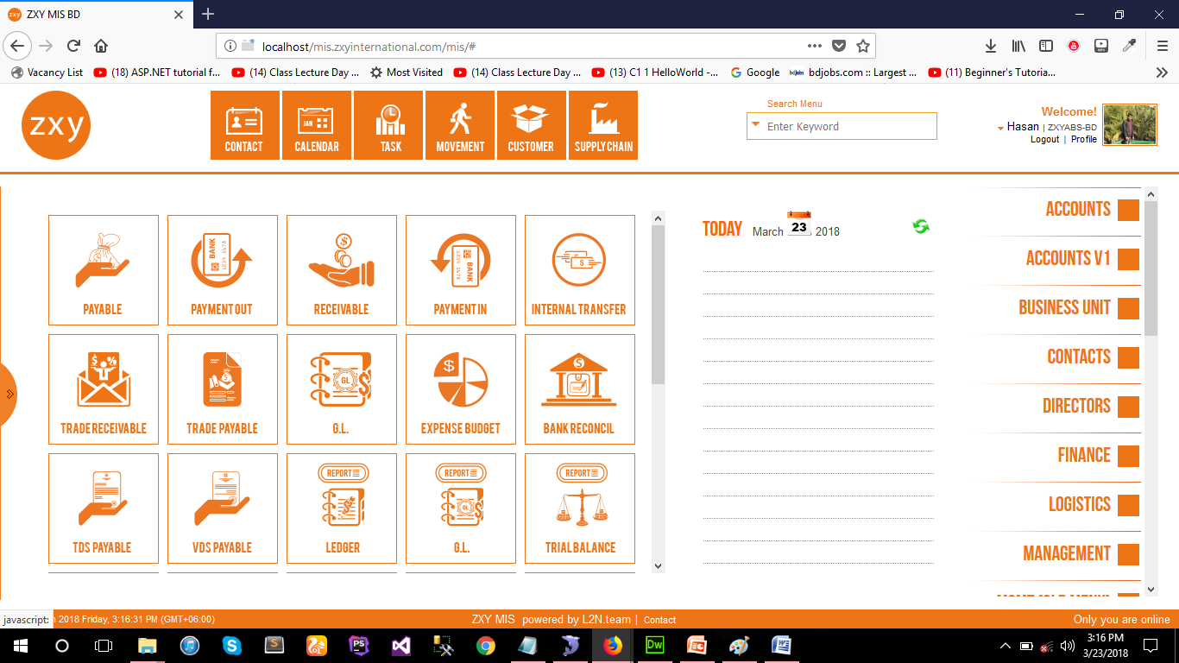

**Fig: Menu**

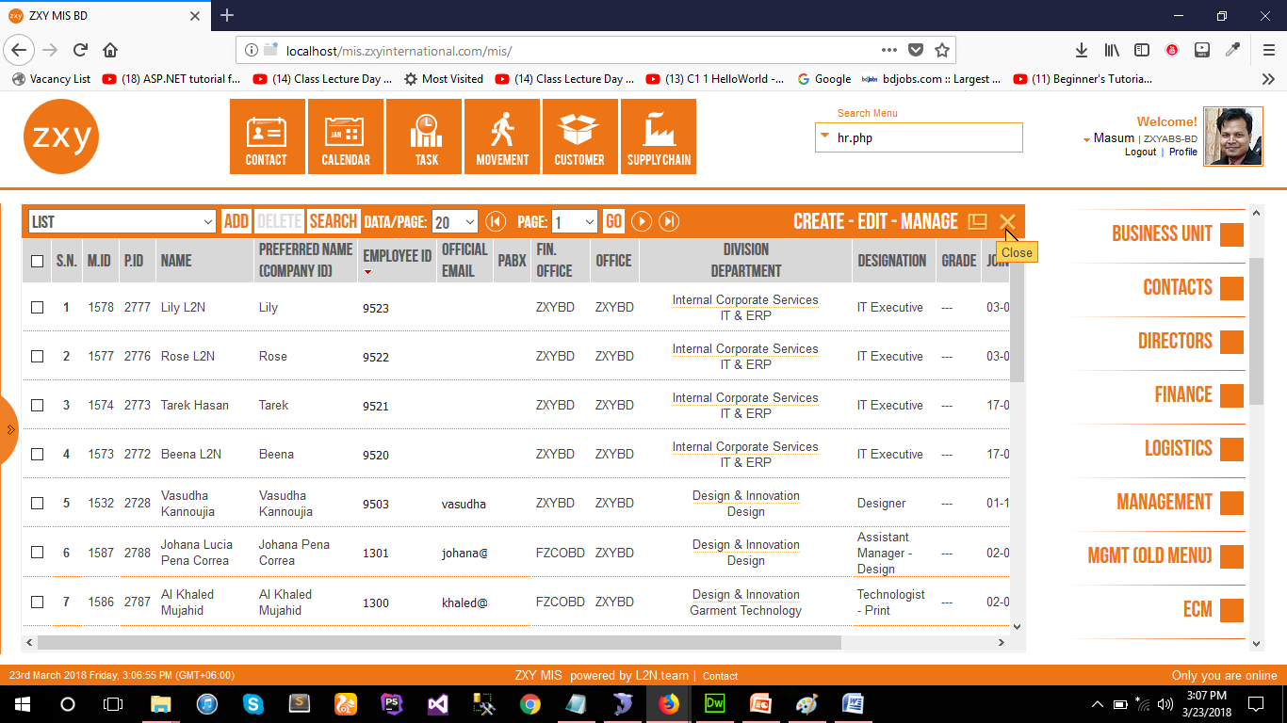

**Fig: List View**

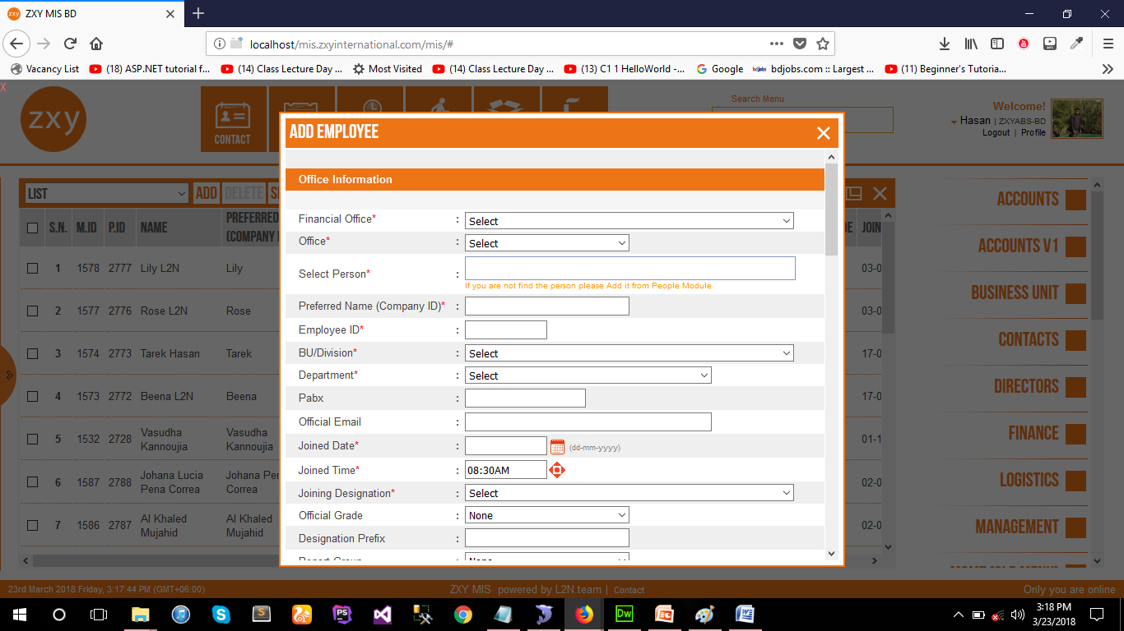

**Fig: Module**

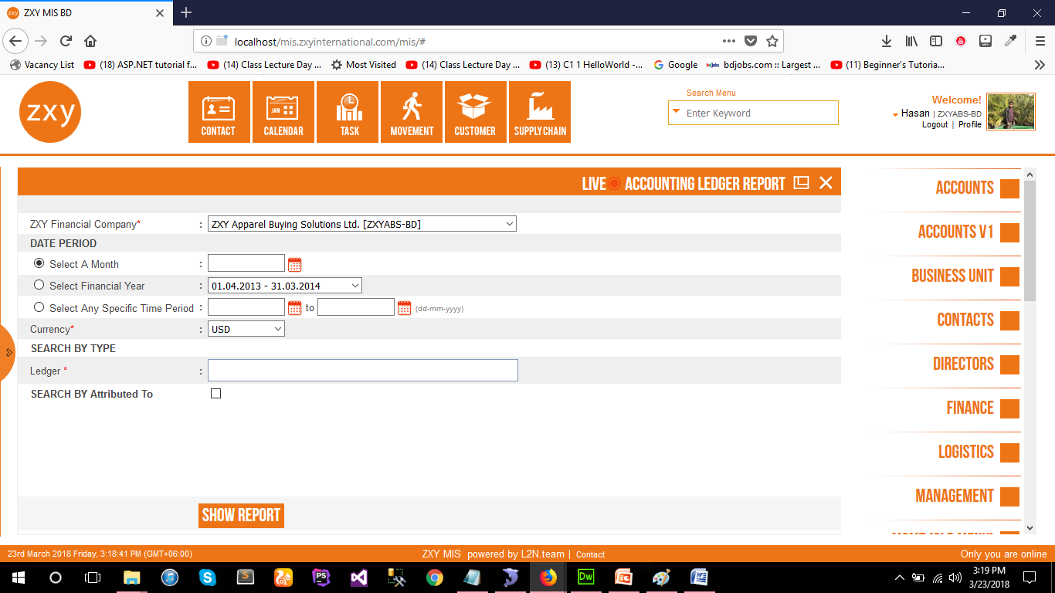

**Fig: Report View Form**

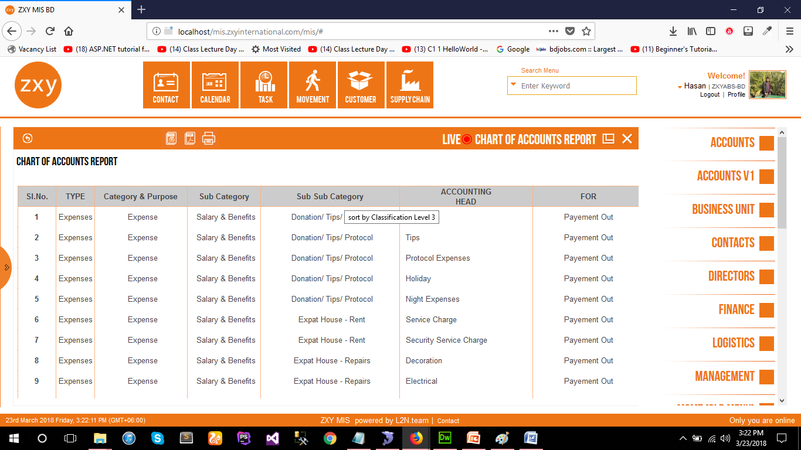

**Fig: Report Details**

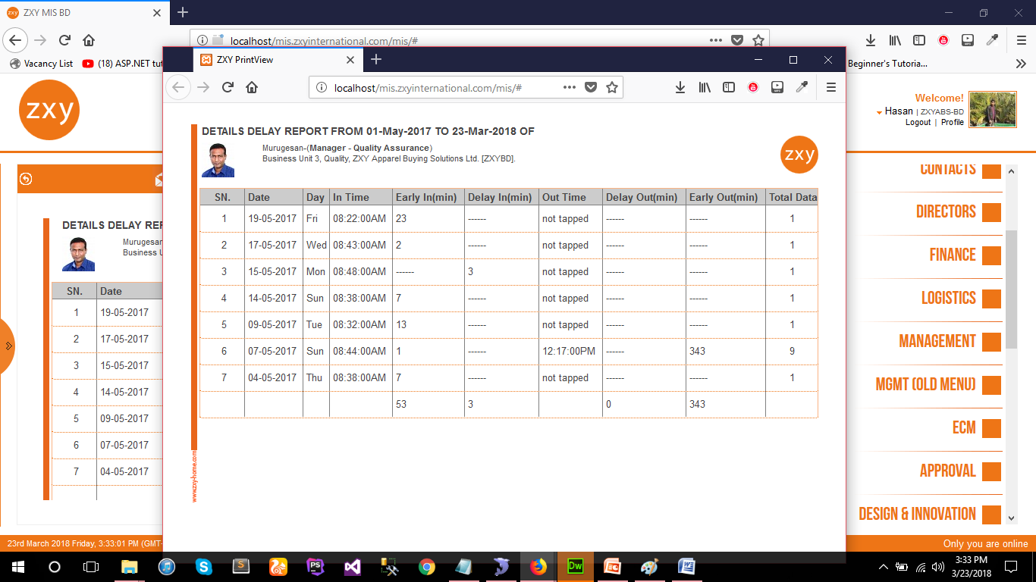

**Fig: Report Print View**

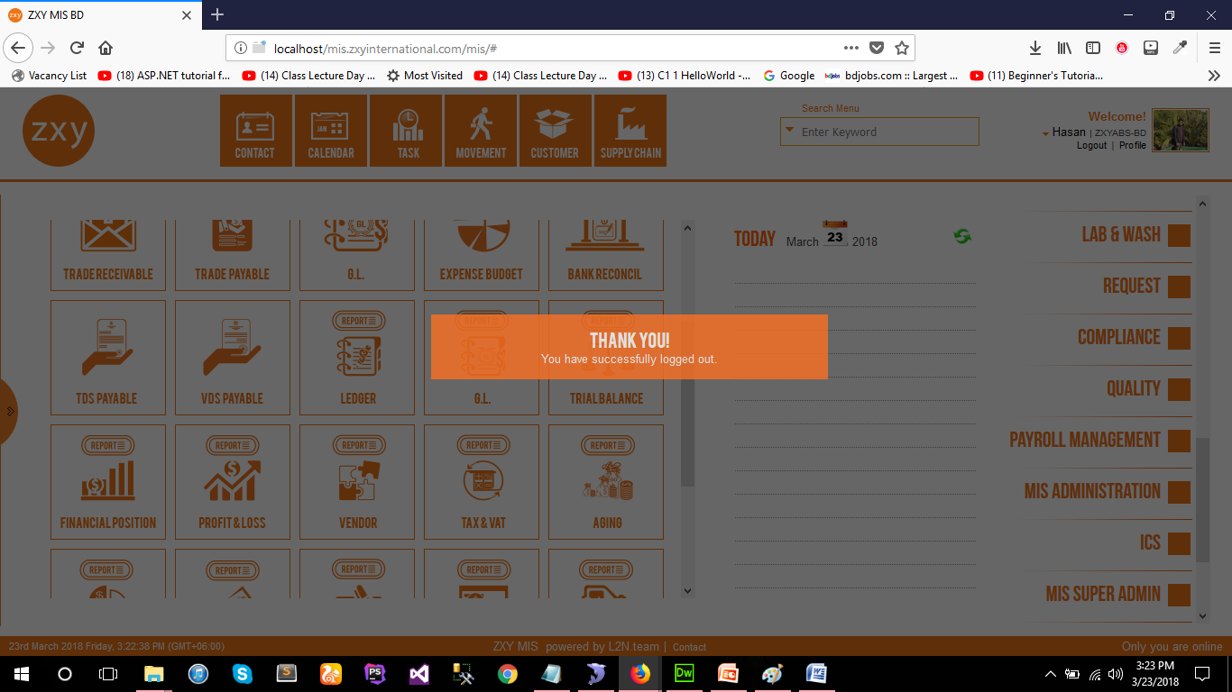

**Fig: Log Out**

# Project 2:

**MIS for L2N Software Ltd**

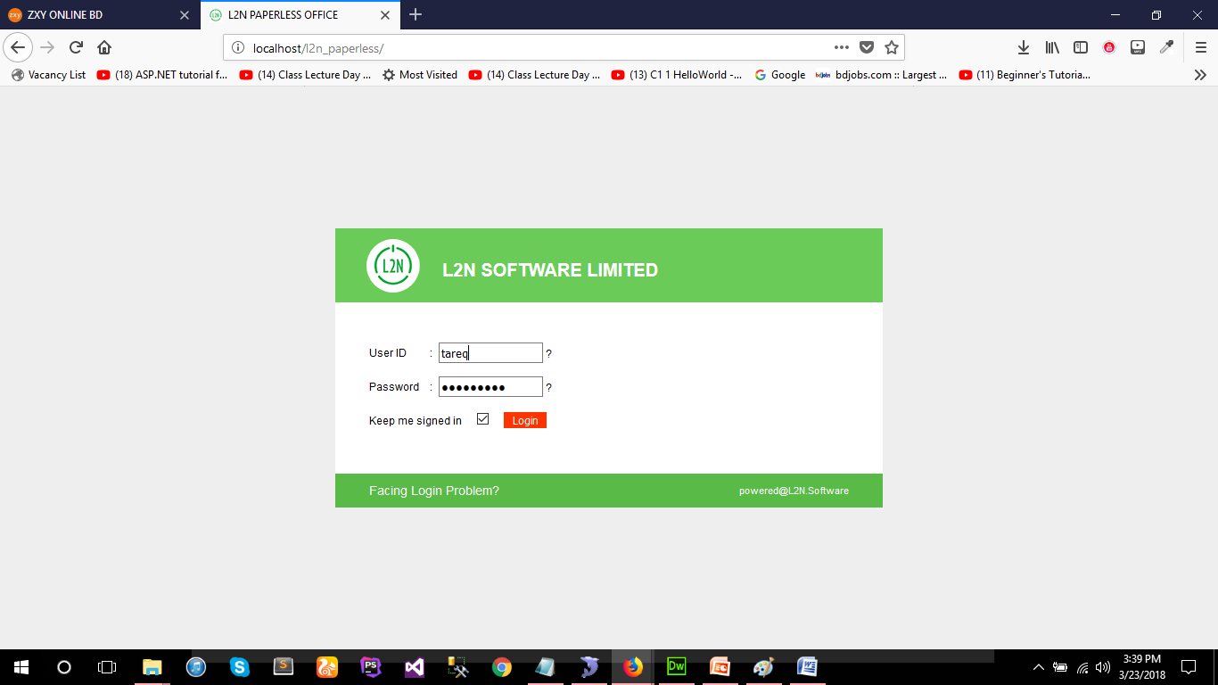

**Fig: Login page**

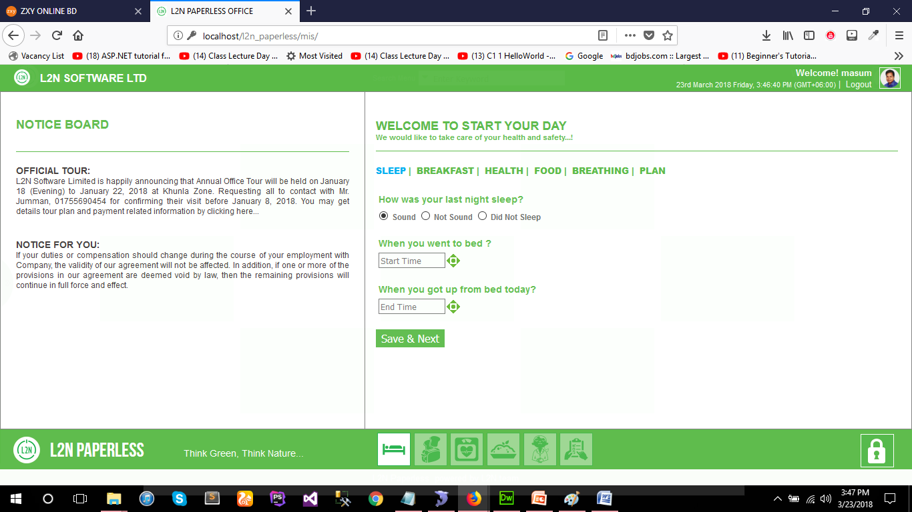

**Fig: Dash Board**

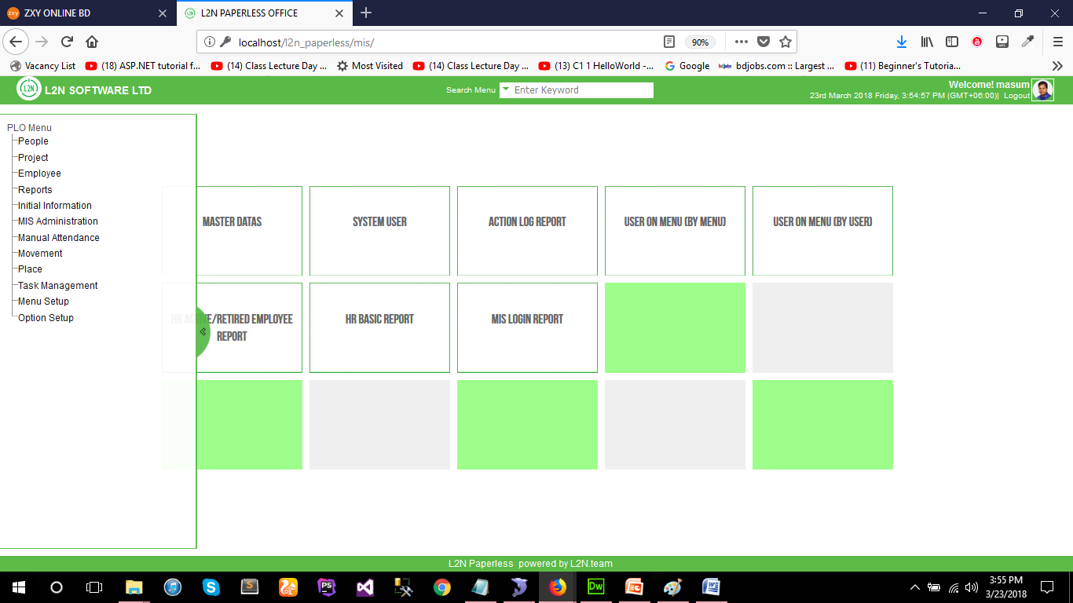

**Fig: Menu Board**

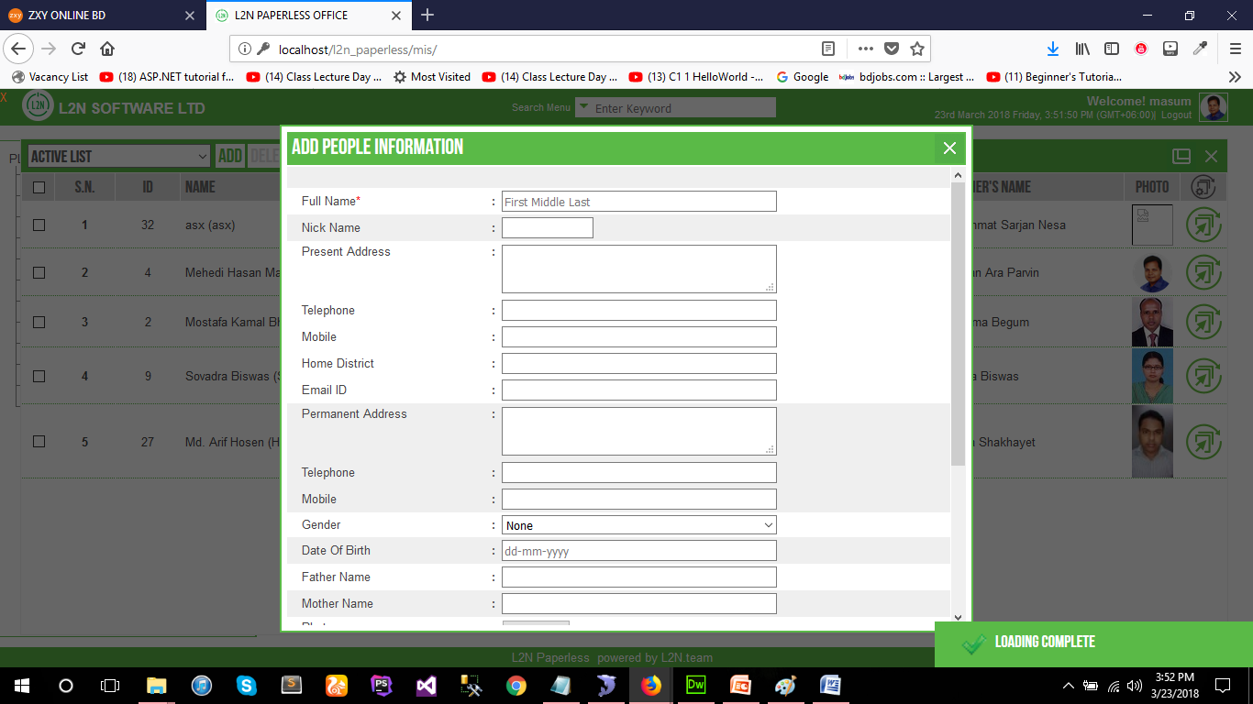

**Fig: Module**

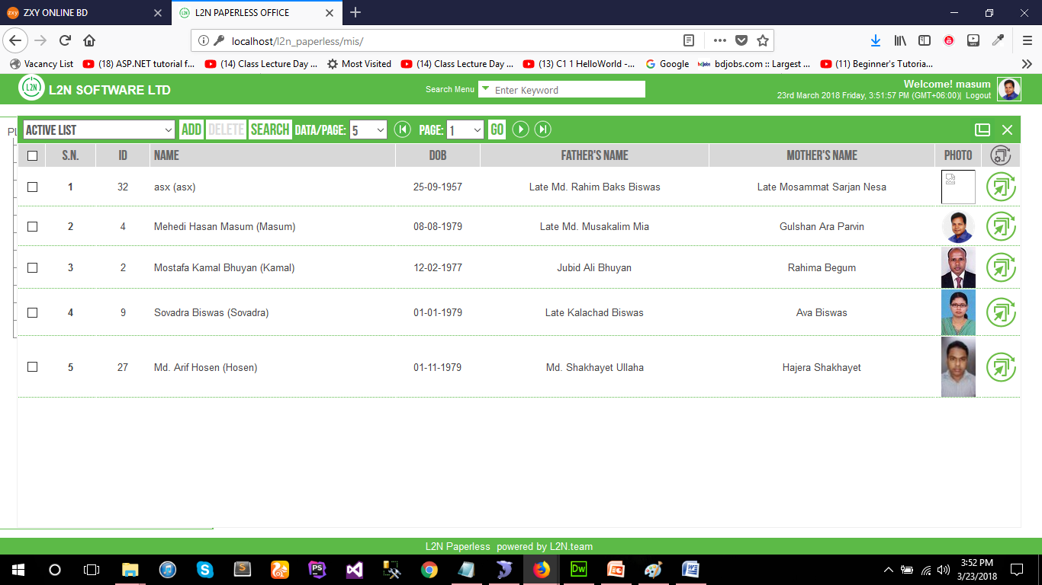

**Fig: List view**

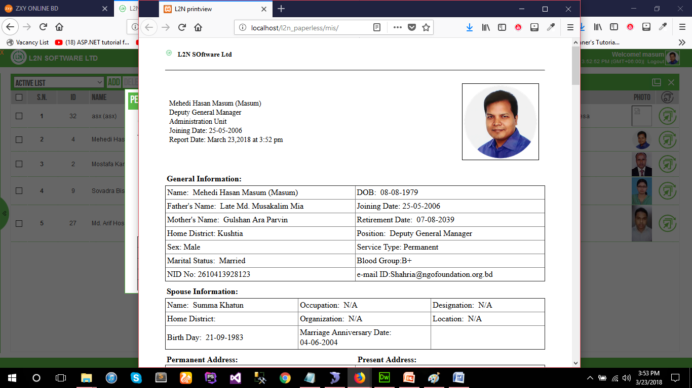

**Fig: Print Details View**

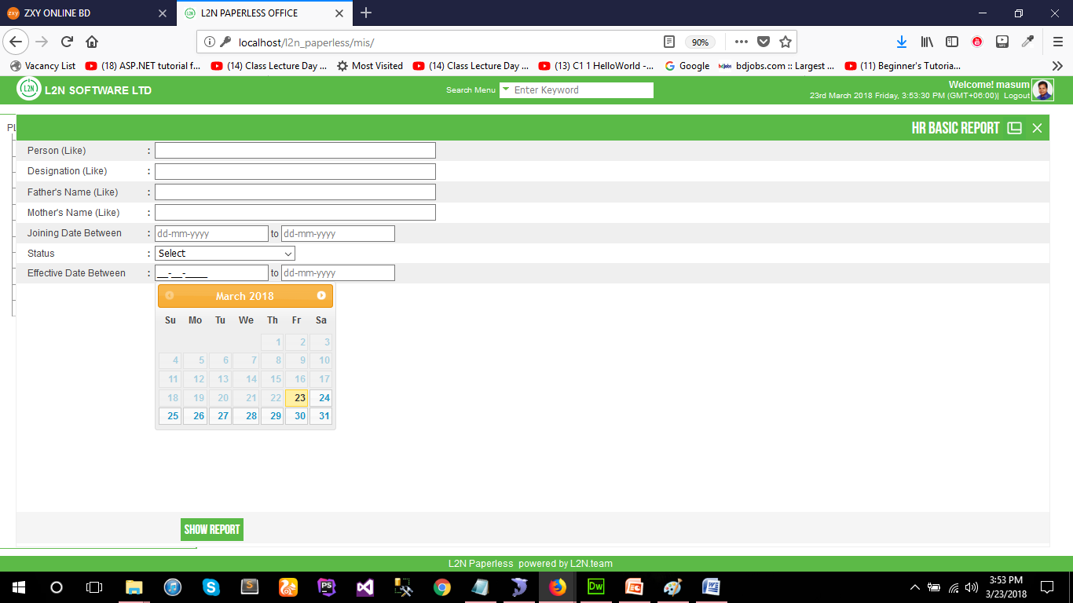

**Fig: Report View**

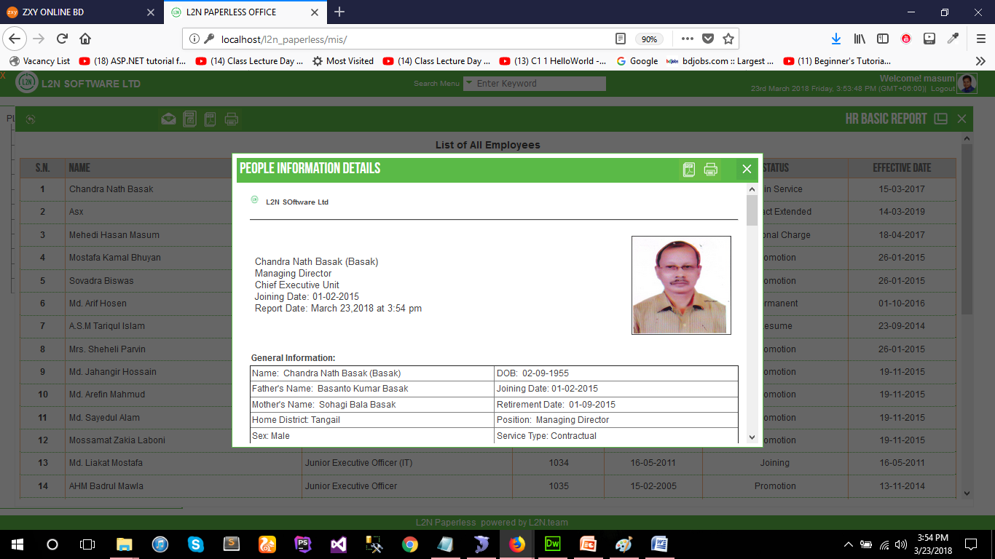

**Fig: Report Details View**

# Project 3:

**Accounts Software for BNF.**

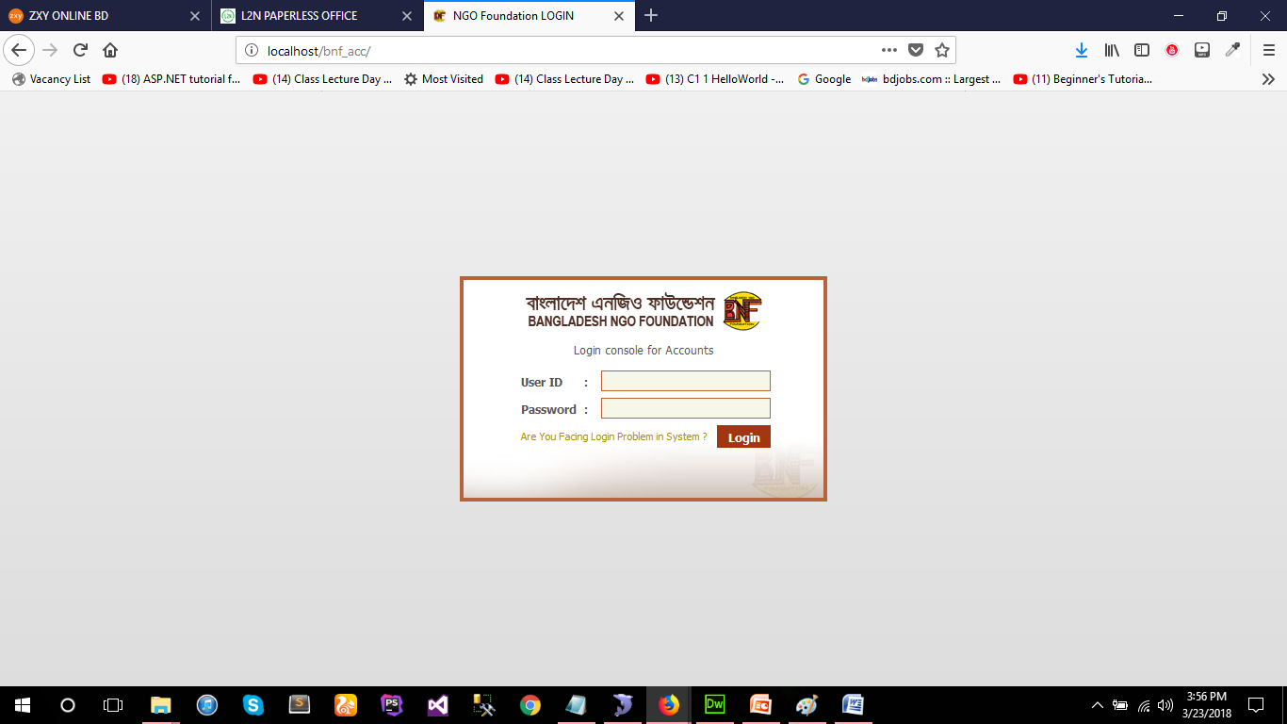

**Fig: Login**

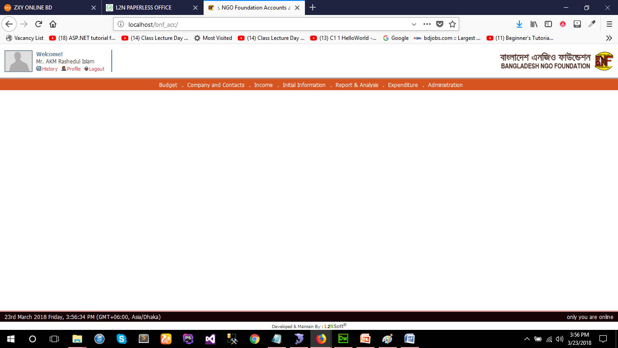

**Fig: Dash Board**

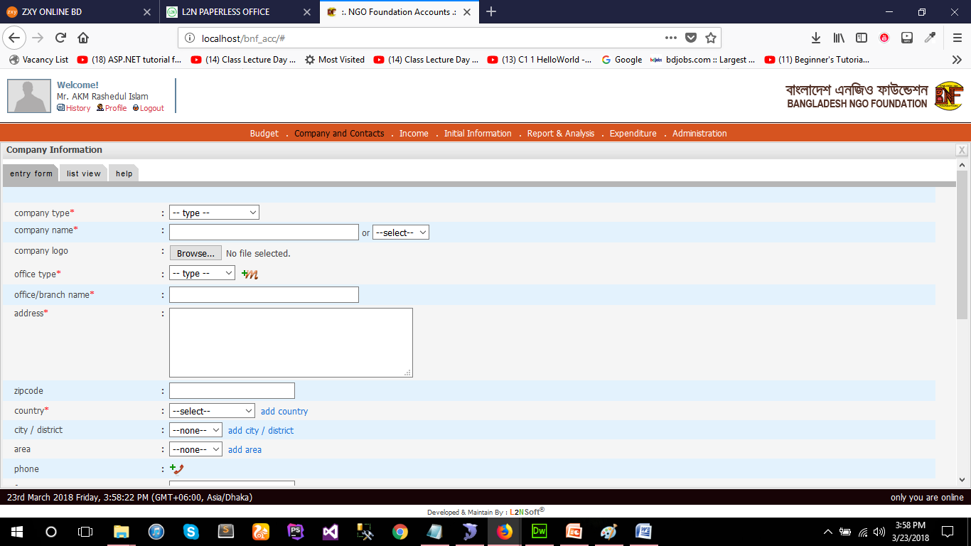

**Fig: Module**

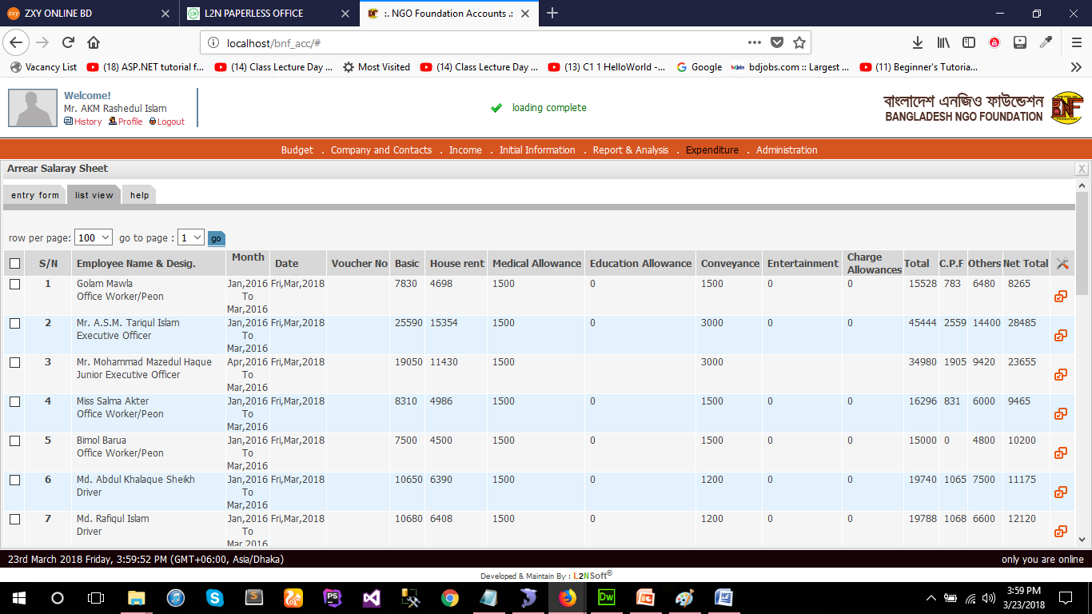

**Fig: List View**

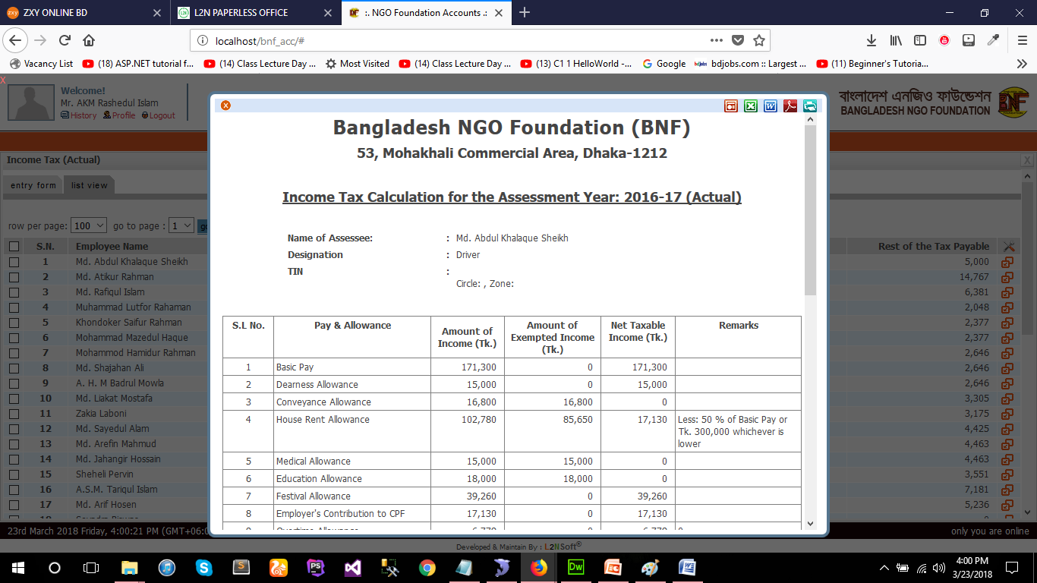

**Fig: Details View**

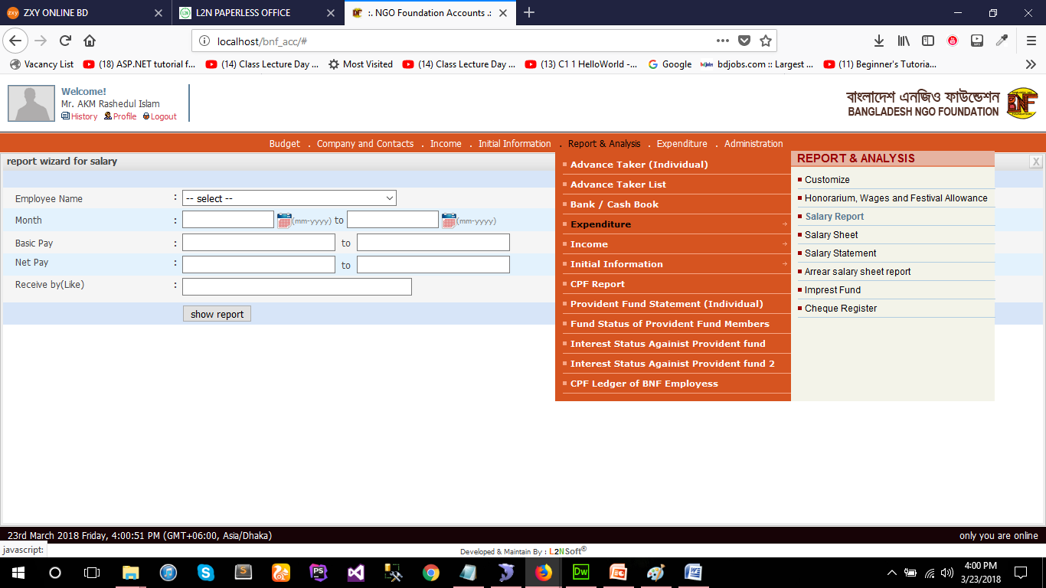

**Fig: Report form**

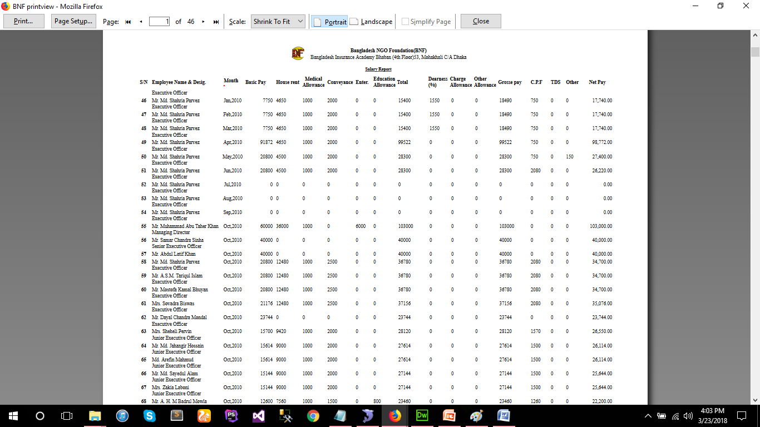

**Fig: Report Details**

# Project 4:

**MIS Software for REHAB BD.**

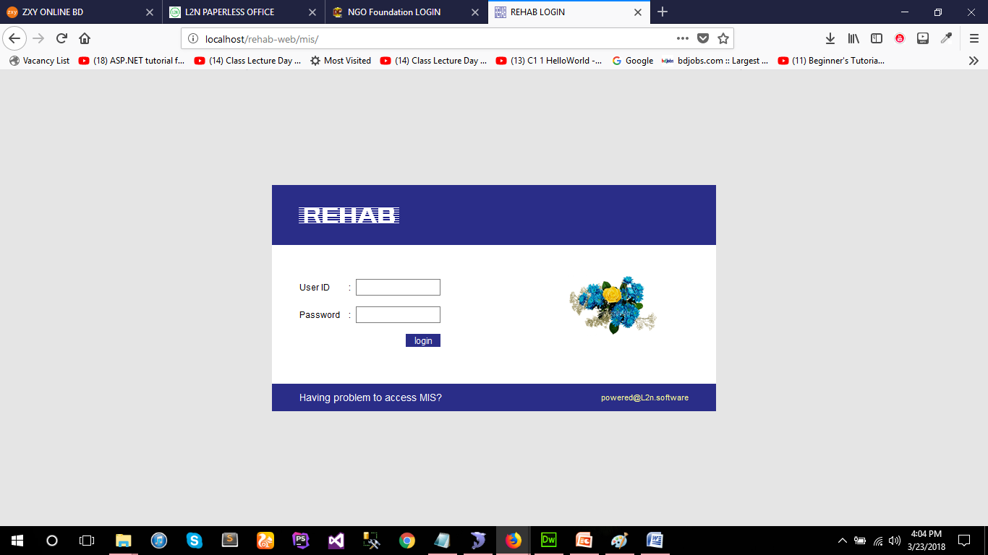

**Fig: Login System**

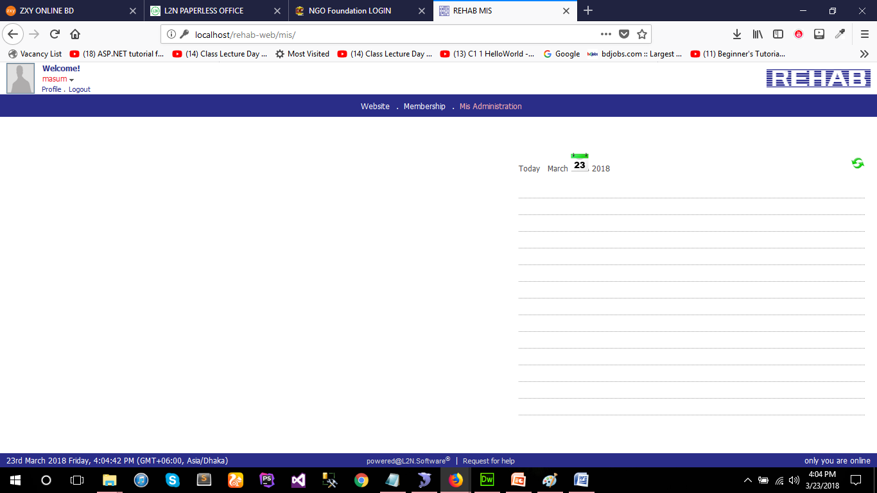

**Fig: Dash Board**

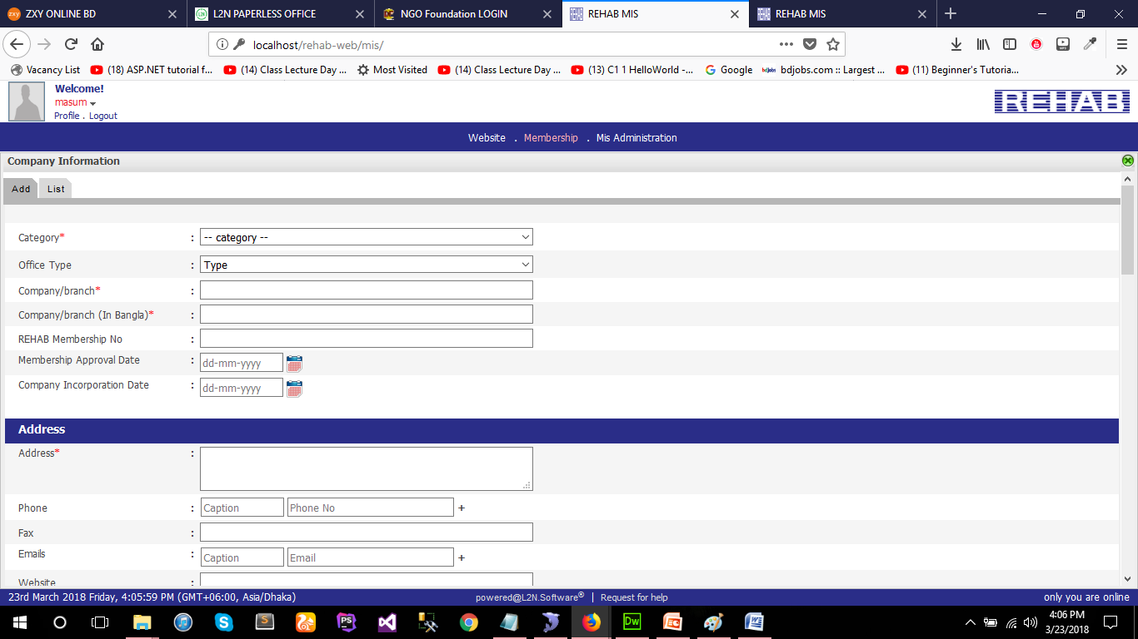

**Fig: Module**

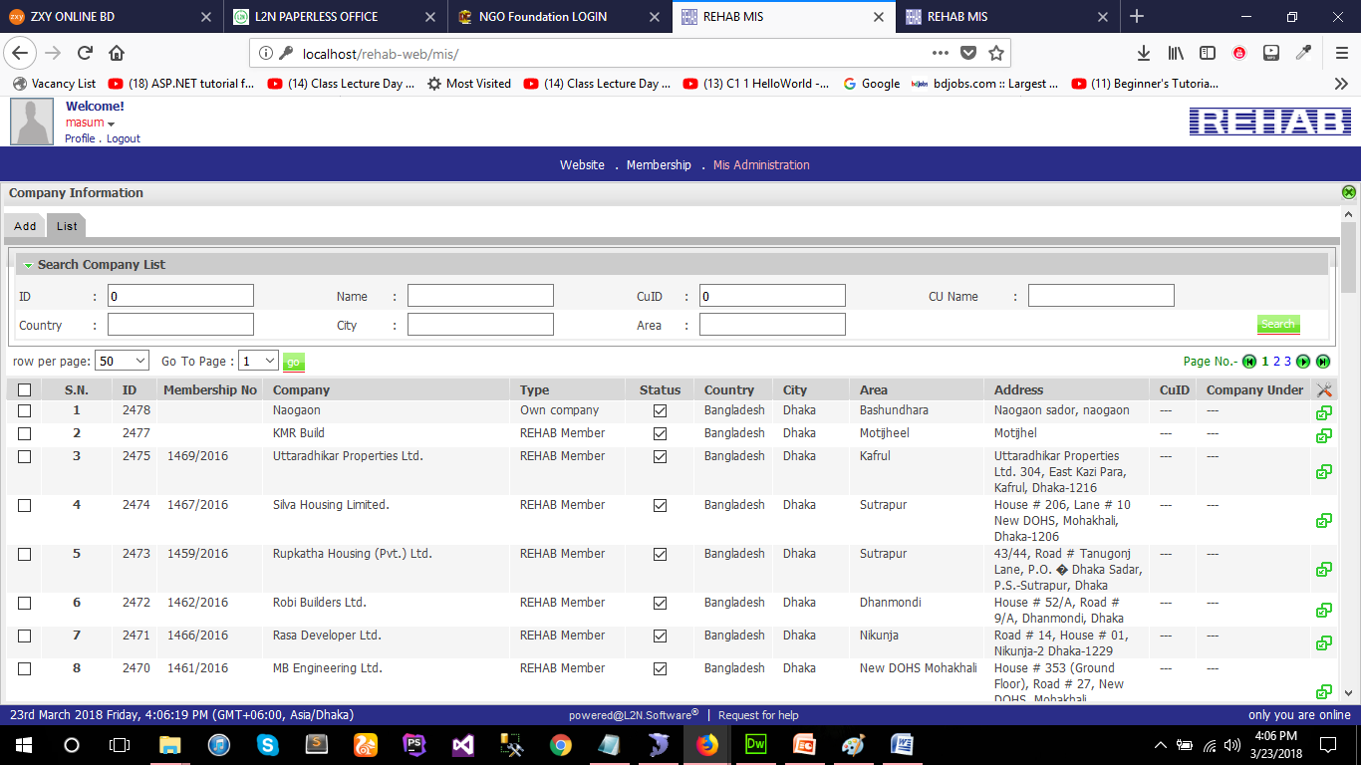

**Fig: List View**

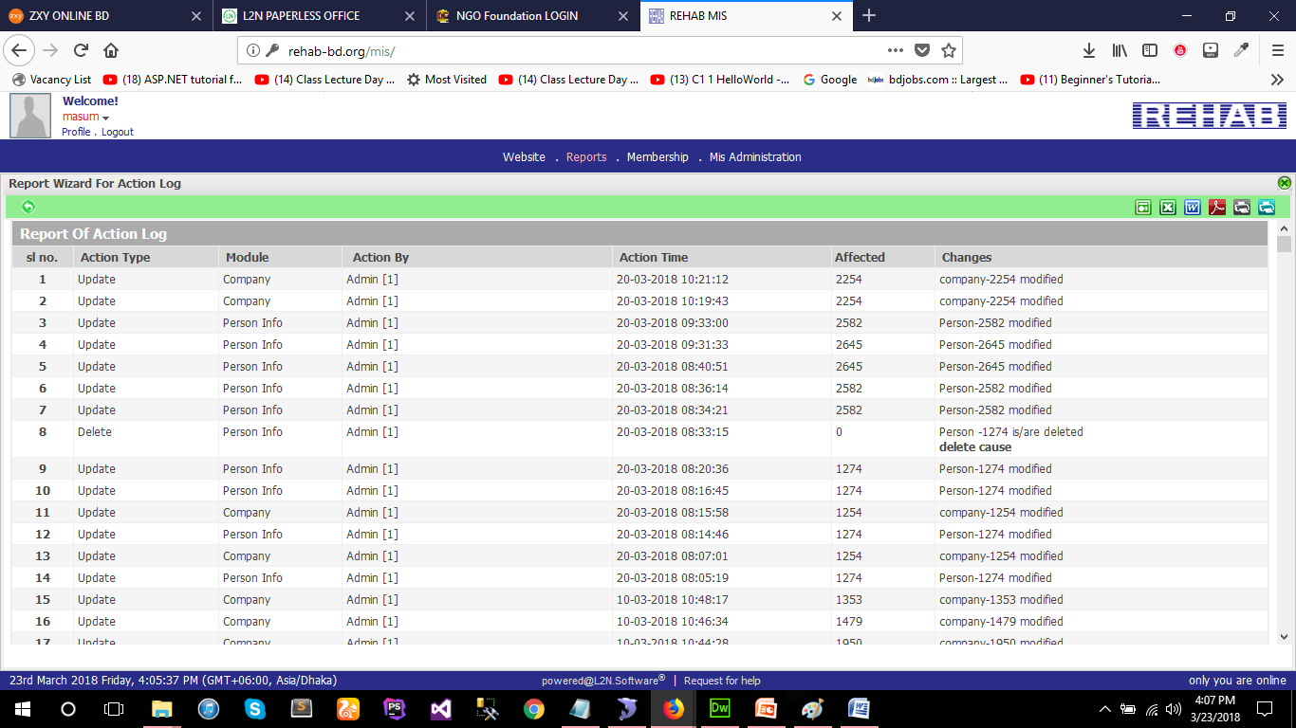

**Fig: Report Details**

# Project 5:

**Website for REHAB BD. (http://rehab-bd.org/)**

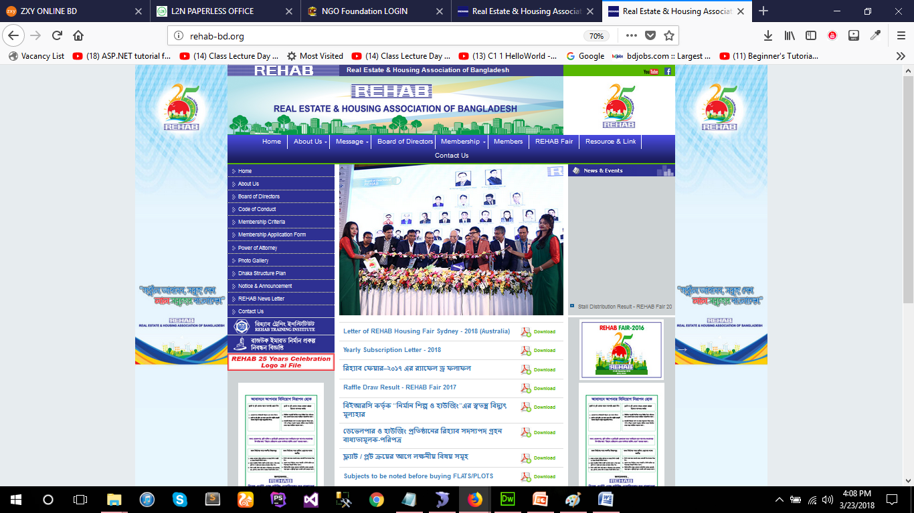

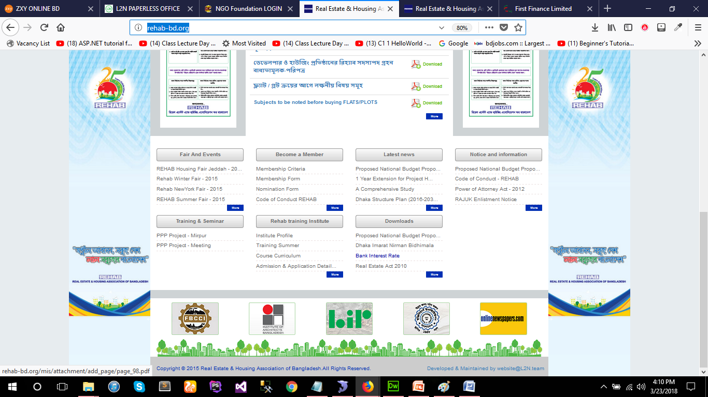

# Project 6:

**Website for First Finance Ltd. (http://first-finance.com.bd)**

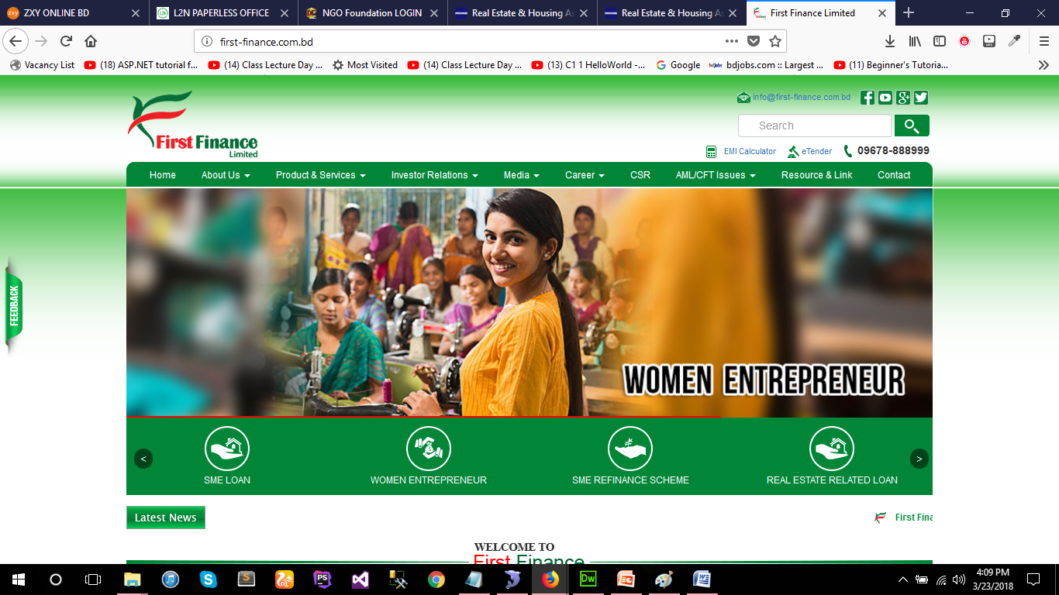

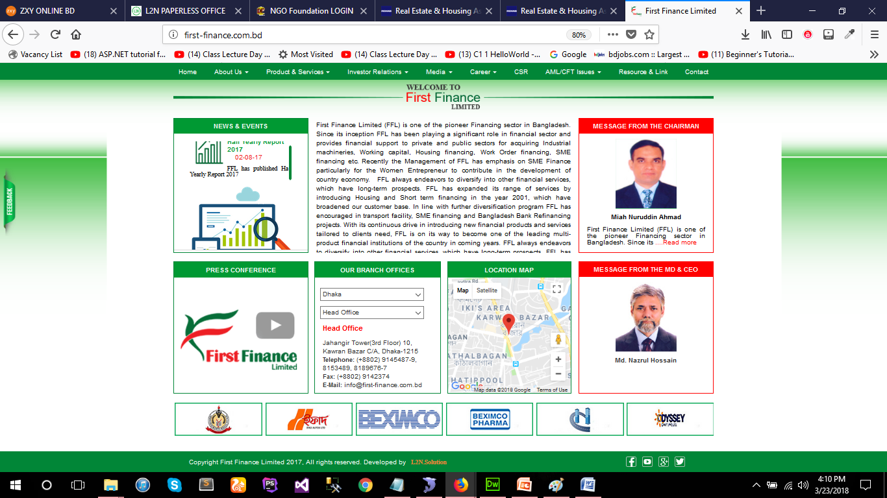

# Project 7:

**Website for Bakhrabad Gas Dristibution ltd. (http://bgdcl.org.bd)**

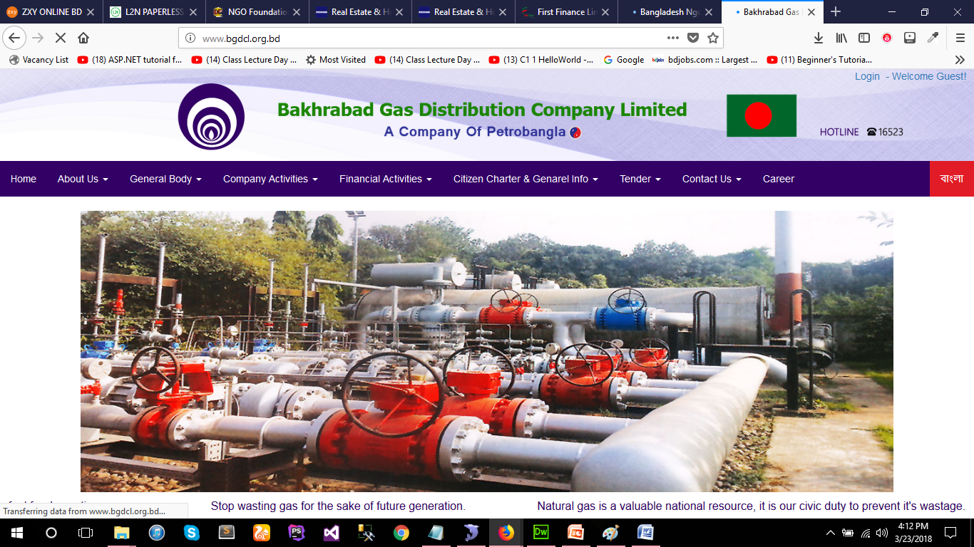

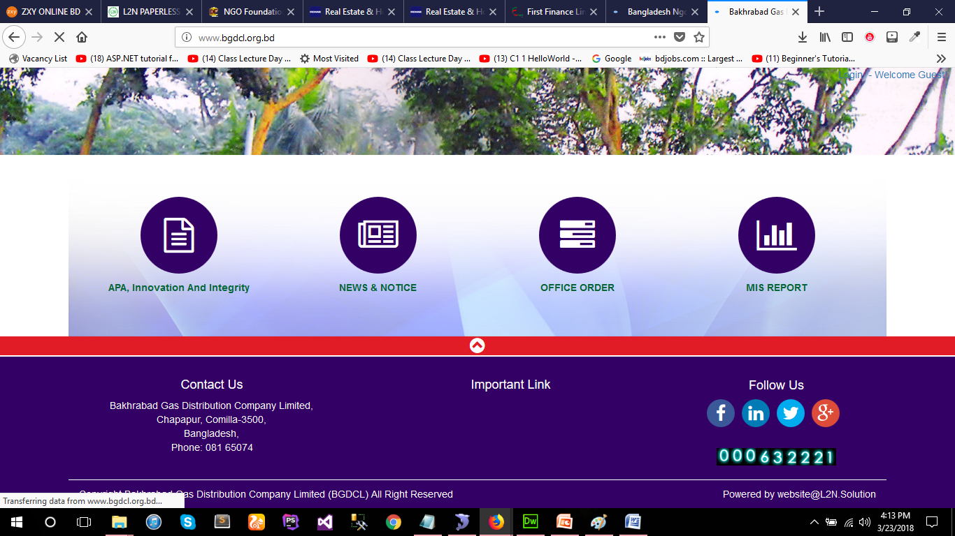

# Project 8:

**Website for barapukuria Coal ltd. (http://bcmcl.org.bd)**

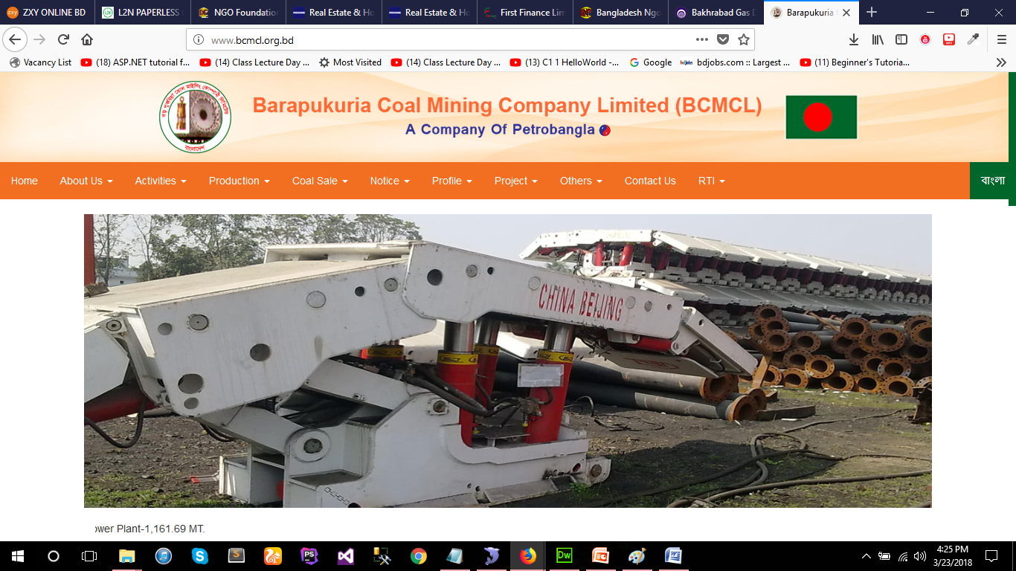

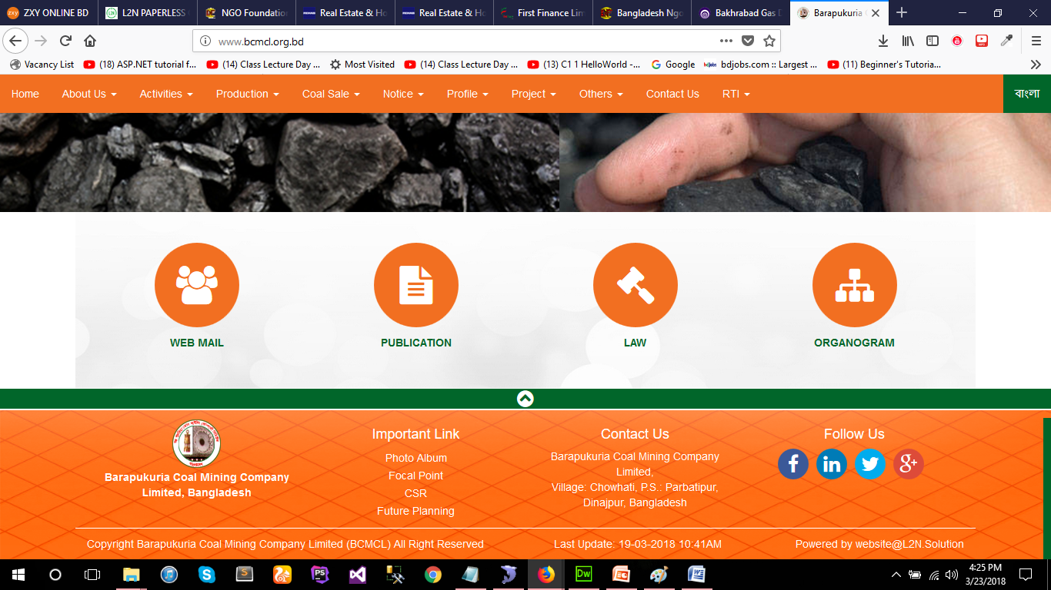

# Project 9:

**Website for Bangladesh NGO Foundation. (http://www.ngofoundation.org.bd/)**

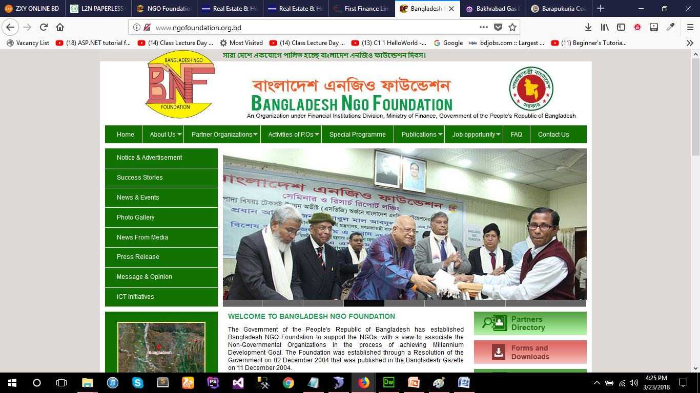

Thank You